# Developer Diary

### 3/11/2020 - 9/11/2020

Studied to break the Game Design Brief so that could make it clear what I needed. The more I read into it there harder it was to follow. At the beginning of the Document It stated that “The game is an endless space shooter”. This in my mind seem like it was an endless runner that the player could shoot and fly around space. The more I read into the document the more it become clear that the game had 2 game types. It stated that “the game is a rail shooter” which confused me a bit as I thought it was an endless runner. I would need to send an email to the Design Brief Owner (Aleksander Hryciuk) and clarify a few bits. Overall, the game design seems to be okay and the controls would only be the mouse to shoot. Alex answer most of the questions I asked, and it was a rail shooter that the player would not be able to control the movement of the ship.

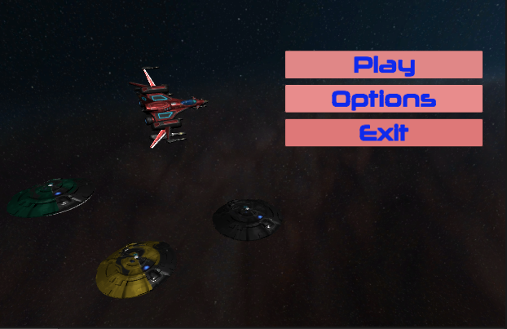So, I created a Unity 3D Project and started working on the main menu and UI of the game. I created a Repository for GitHub and Pushed the Unity Project up there. The Main Menu only had three button which had the function to play, change options and quit.

### 10/11/2020 - 15/11/2020

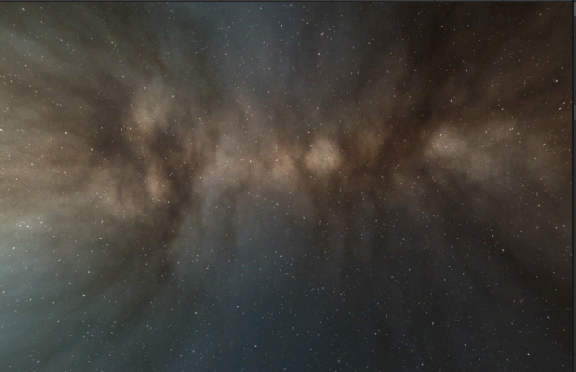There wasn’t any References to assets so I have a free rain of what the level looks like which is okay but there could have been a few assets to pick from. The Background will be a Skybox which will be the centre of the game as it will be around the player’s ship. These backgrounds will be the same for each level

### 16/11/2020 - 22/11/2020

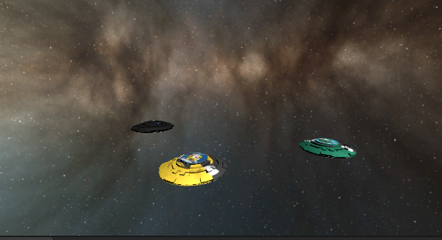Next the Ships will be added and that includes the enemy ships. Some were obtained by the assets store, but the Enemy Flying saucer was a problem to get as it would cost money to get from the Unity Asset Store. So instead I download from [[1]](https://free3d.com/3d-models/ufo) from a website in References below. The enemy ships were basically all the same ship as the document stated with different colours. There would be three different types which would rotate and have different abilities (Grunt, Sergeant, Rocket) and the mothership would be taken from the website as well.

The player ship would be tricky to control, as I haven’t seen many games that are controlled by the movement of the mouse. I knew I would have to do a lot of research and see if I could see what the scripts of the player would look like. I found 2 scripts but I’m not happy with them. The function of the Scripts lets the player look around the world in 360 degrees and let them roll the ship. The Script is complicated, and I want only want the player to view what is front and be able to shoot at the enemies. Having the player only shoot and not move is a problem. I was nearly thinking of putting the player on a timeline and get the player to shoot around a plane. But I’m still working on things with the script. The player can shoot with the left mouse click and I’m working on a special attack on the right mouse click.

In the next few days, I hope to have a better script that lets the player not move off the camera and only be able to shoot at on coming targets. The Bullets is a Particle Systems that has a long range.

### 23/11/2020 - 26/11/2020

This week I’ve started working on Stars being visible in the camera which will be centred around the player and I found a tutorial on YouTube to help me[[2].](https://www.youtube.com/watch?v=YuPEmRXtwIg)

References

[1]: <https://free3d.com/3d-models/ufo>

[2]: <https://www.youtube.com/watch?v=YuPEmRXtwIg>

[3]:Asteroids; <https://www.youtube.com/watch?v=D4HaUVjmGzU>